Direct and Indirect Emissions
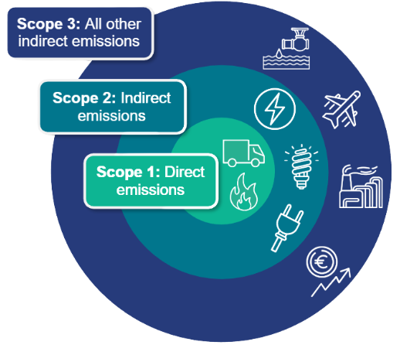
Greenhouse gas emissions are categorised into three groups or ‘scopes’ by the most widely-used international reporting and accounting standard, the Greenhouse Gas (GHG) Protocol.
The centre of the circle represents Scope 1. These are direct emissions that your business is responsible for such as gas burned to heat your offices or fuel used to power your vehicles.
As you move outwards the emissions are incurred indirectly. Scope 2 is indirect emissions from purchased electricity, but can include heat, steam or compressed air too.
Scope 3 is all other indirect emissions associated with the goods and services purchased and sold throughout your industry’s value chain.

Scope 1: Direct Emissions
Scope 1 covers direct emissions from owned or controlled sources. This includes fossil fuels burned on site either to provide heat or power (via a generator for example). It also includes fuel used in company-owned vehicles.
Some businesses might also emit greenhouse gases other than carbon dioxide. For example, agriculture’s carbon footprint might also include the release of nitrous oxide and methane from livestock and manures.

Scope 2: Indirect Emissions
Scope 2 covers indirect emissions from the generation of purchased electricity, steam, heating, and cooling consumed by your business.
Aim to reduce these quantities of energy and then take steps to source energy from renewable sources (e.g. wind or solar power).

Scope 3: Indirect Emissions
Scope 3 includes all other indirect emissions that occur in a company’s value chain.
This can make up the largest share of the carbon footprint, especially for office-based compnaies, covering emissions associated with the purchase and shipping of goods, business travel, water and waste disposal and even services.
Source: SEAI Energy Academy www.seai.ie/about/tools/energyacademy

